ARCHDES 700 | ADVANCED DESIGN 1 | TOPIC OUTLINE | SEM 1 2019
Advanced Design 1 is the integrated design project for the MArch(Prof). Students are required to address a challenging and conceptually complex architectural design and to achieve a fully resolved design project, together with developed design studies sufficient to explain the proposed building’s construction, structure, materials and natural environmental performance. Emphasis will fall upon the development of strategic responses to differing, changing or extreme environmental conditions. Focus on site, thermal, natural environment, material and ecological issues.
Uwe Rieger

BRICK BAY FOLLY - THE WOOD PAVILION
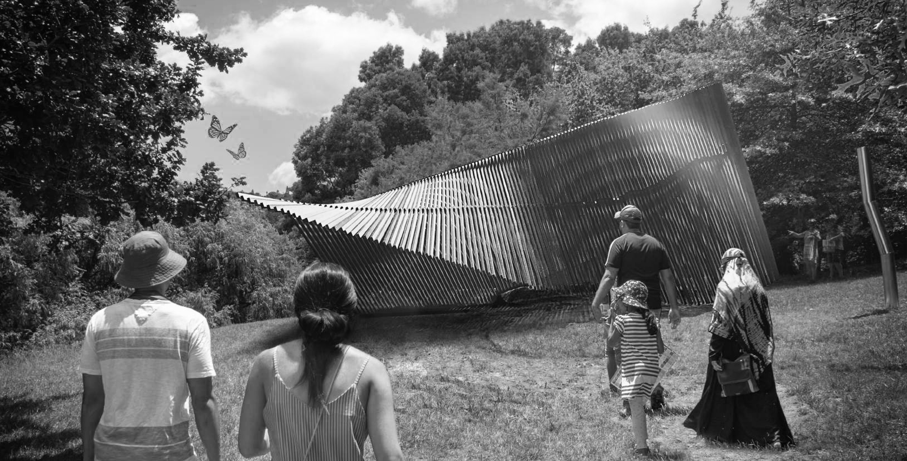

GENERAL COURSE INFORMATION
Course : |  | Advanced Design 1 ARCHDES700
Points Value: |  | 30 points
Course Director: |  | Sarosh Mulla: s.mulla@auckland.ac.nz
Course Co-ordinator: |  | Aaron Paterson:aaron.paterson@auckland.ac.nz
Studio Teacher: |  | Uwe Rieger
Contact: |  | u.rieger@auckland.ac.nz
 | Location: |  | 17 Arabella Lane, Snells Beach
 | Hours: |  | Tuesday and Friday 1:00-5:00pm
For all further general course information see the ARCHDES700 COURSE OUTLINE in the FILES folder on CANVAS.

INTRODUCTION
The course investigates the intersection between sculpture and architecture with temporary structures that intentionally serve no utilitarian purpose.
Architectural follies are found all over the world, and their purpose is to inspire and delight audiences, but even more importantly folly projects provide a fantastic opportunity for emerging architects to test their ideas on a real life project, manage a construction team, solve contingencies and participate in physical construction. The process is as important as the result and once complete, students will have a better understanding of detail development at full scale.
"What if the ordinary timber studs that make up our domestic houses were free to express themselves in a sculpture park?"
This course explores and aims to explicitly express the fundamental qualities of wood as an architectural material of lightness and componentry.
The integral element that accompanies the conceptual and developing design phases are the exotic species of trees and the generous shading they provide. The interaction of students with the site should culminate in a design which enhances the spatial characteristics of the area. The product of the design revolves around the idea of creating a space that allows and encourages the visitors to dwell.
Students will be assigned specific roles and tasks. They a are required to address a challenging and conceptually complex architectural design and to achieve a fully resolved design project, fit for construction after the 12 week design course.

TOPIC STRUCTURE AND CONTENT
See program dates below for key hand ins and presentations throughout the semester.
SPECIAL NOTE:
The site visits are not part of the course. The realisation and setup will yake place after the course and are not part of it.

Week | Date | Event
Week 1 | Mon 4.3  Tue 5.3  Fri 8.3 | Consultant Meeting (JASMAX)  Material Study  Consultant Meeting (JASMAX)
Week 2 | Tue 12.3 | Consultant Meeting (Leighs Construction)
 | Fri 15.3 | Structural Development
Week 3 | Tue 19.3 Fri 22.3 | Site Analysis  Digital Structural testing (Multiframe)
Week 4 | Tue 26.3  Fri 29.3 | Development of constructibility  1:20 Concept model
Week 5 | Tue 2.4  Fri 5.4 | Detail Development  Detail Development
Week 6 | Tue 9.4 Fri 12.4 | Crit Preparation  MID CRIT PRESENTATION
 |  | MID-SEMESTER BREAK
Week 7 | Tue 30.4  Fri 3.5 | Mid Semester Feedback  Materiality Testing
Week 8 | Tue 7.5 Fri 10.5 | 1:1 Detail Models  1:1 Detail Models
Week 9 | Tue 14.5 Fri 17.5 | Consultant Meetings  WEEK NINE PRESENTATION
Week 10 | Tue 21.5 Fri 24.5 | DEVELOP PRESENTATION  Consultant Meeting
Week 11 | Tue 28.5 Fri 31.5 | DEVELOP PRESENTATION  Consultant Meeting
Week 12 | Tue 4.6 Fri 7.6 | FINALISE PRESENTATION  WEEK TWELVE PRESENTATION

RESOURCES
Submission Guideline https://static1.squarespace.com/ static/5acf3c51f793927313dbec1e/
t/5c4fb4964ae237b6d9c40152/1548727456409/Brick+Bay +Folly+2019+-+Submission+Guidelines.pdf
Site Survey https://static1.squarespace.com/ static/5acf3c51f793927313dbec1e/
t/5bdba66a03ce64828d7c4109/1541121643512/Site
+Diagram+-+Lakeside.pdf
REQUIRED PRODUCTION
- 3D Images
- 3D Diagrams
- Working Drawings
- Detail drawings
- Individual A4 Journal
- Models (1:20 model+site, 1:5 detail models, 1:2 or 1: 1 junction model
- Book (concept, development, details, financial documentation, timeline, shop drawings, final design)

DESIGN REPORT
All AD1 students are required to prepare a Design Report. This will take the form of a 350-400 word abstract. An abstract is a condensed piece of writing that highlights the major aspects of your design project: the content, context, scope and outcomes of the design research. The abstract should be a finely crafted piece of text accompanied by a single image of your project. A template will be given and all abstracts must be submitted in the template both in print and in digital format (venue TBC). All final Design reports are due on Friday 31 May so that they can be published and circulated to your critics well ahead of crit week.
ASSESSMENT & FEEDBACK
This course is assessed as 100% coursework. Conversational feedback is given throughout the semester. Written feedback, with indicative grading, is given at a date around the mid-point of the semester. All further information regarding assessment is available in the ARCHDES 700 Advanced Design 1 Course Outline (on Canvas).

LEARNING OUTCOMES
General Course Outcomes: On successful completion of this course students should be able to:
- Theory: Show evidence of development of critical thinking and conceptual consistency throughout the design process.
- Architectonics: Demonstrate abilities to advance conceptual thinking and design propositions through identifying and addressing issues of materiality, structure and construction.
- Performance: Show abilities to advance conceptual thinking and design propositions through interrogating and addressing in depth the natural environmental, contextual, and programmatic factors underlying the project.
- Form and Space: Demonstrate skill in the development of threedimensional architectural form and space, both exterior and interior.
- Media: Display skill in the communication and development of conceptual, preliminary and developed design propositions through the strategic use of architectural media.
Specific Topic Outcomes: This studio topic will engage the general course outcomes in the following ways:
- Theory: Critical thinking and conceptual consistency will be challenged upon the construction process. The process of developing from a concept to a working product will involve numerous design iterations and scaled prototypes. Critical thinking is required to assess every iteration to analyse the faults.
- Architectonics: The scale of the Wood Pavilion challenges us to address the issues of materiality, structure and construction. Essentially the project is about materiality. Specifying the materials, understanding the issues regarding gravity, tolerance and how they meet the ground. Whether it is modular or component construction.
- Performance: A key understanding of the context is the driver for the design. The design of the complex structure is attached to the view, ground, the clients and with the users in mind.
- Form and space: The three-dimensional space is developed upon investigations of the notion of the architectural folly and the relationship between the interior and exterior.
- Media: Design will be developed with architectural models and scaled prototypes of 1:5, 1:2 and 1:1. The team will also be synthesizing multiple digital media forms. Throughout the development process, iterations and simulations are also generated through engineering software

