SCHOOL/DEPARTMENT: Architecture & Planning

COURSE OUTLINE: ARCHDES700 / Semester 1, 2017

GENERAL COURSE INFORMATION
Course Code: | ARCHDES700
Course Title: | Advanced Design 1
Points Value: | 30 points
Prerequisites: | N/a
Restrictions: | N/a
Course Director: | Prof Andrew Barrie, Room 335, Building 421, a.barrie@auckland.ac.nz
Course Co-ordinator: | Dr Ross Jenner, Room 547, Building 421, r.jenner@auckland.ac.nz
Teaching Staff: | Lada Hršak (info@ladahrsak.com) & Esther Mecredy (emecredy@gmail.com)

2.0 CLASS CONTACT HOURS
Monday, Tuesday & Friday, 1pm – 5pm; Level 3 Design Studios, Building 421.

3.0 COURSE PRESCRIPTION
A studio based inquiry into an architectural topic approved by the Head of School of Architecture and Planning intended to facilitate in-depth study that is both tailored to a student's own interest and aligned with the School's research clusters, sharing workshops, discussions, pin-ups and tutorials.

WATEREYE: AUCKLAND WATER NARRATIVES

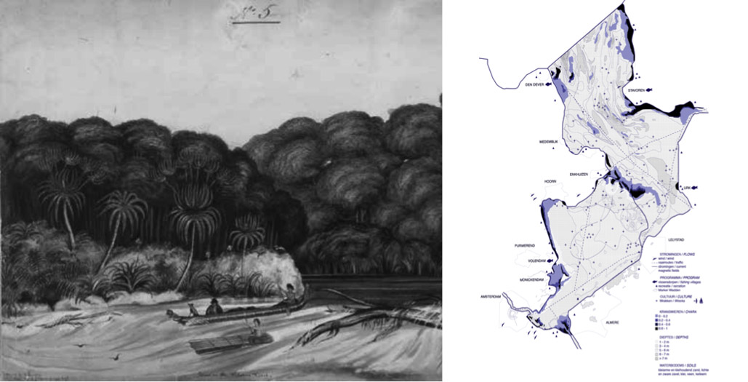
image (left to right): Mokihi Maori bundle raft, R.P.Scofield's 'A Naturalist of the Very First Order, Percy Earl in New Zealand' & Blue layers of Ijsselmeer, Bureau LADA

If world population growth estimates are accurate there will be 9,6 billion people by 2050 and our ecology becomes matter of anthropology. Surviving an extreme climate, scarce resources and unstable politics will require a revision of our actions and desires. “Solar panels will not save us, neither will electric cars: the real solution is to be found in in a series of changes in our social behaviour , or - even better in our desires...”

Design can take an active, experimental role in the emergence of this new society. This studio calls for a dialogue between the land and the sea. In this studio students will develop the ability to look from another's perspective or re-imagine the world from the water’s perspective. ‘WATEREYE ’ is a design laboratory for researching and developing water- related narratives of a possible new ‘society’. This studio asks designers to imagine a society based on the equity between species: the co-existence and balanced habitation of plants, people and animals. Focusing on water as the essential life resource and tackling ecological, social and spatial issues (pollution, climate change, food, politics, ageing, economy etc.) students will design a space for co-habitation between humans and one other species related to water.

This design storyline or narrative shall operate at several scales: reflecting the ecological and environmental large-scale, mapping and personalising the medium scale of Auckland Metropolitan Waters and specific design on the chosen site. The protagonists of this space are hybrids between man and nature - co-creating a water society by cleansing, producing, feeding and hosting.

3.1 Site investigation
Aucklands isthmus hosts a great variety of water spaces and water issues, comprising two bodies of water (Waitematā & Manukau), a deep sea port, cliff erosion, reclaimed land, sewage treatment plants, a series of marinas, causeways that alter natural currents and deposition, man-made beaches (the sand of Mission bay was dredged off the coast of Pakiri), tidal mangrove ecologies, reservoirs, basins lakes (orakei, pupuke, panmure, bethells) estuarial rivers (te Whau, waihorotiu…), islands of the Hauraki Gulf, waterfalls in the Waitakeres…

The large-scale ecological and environmental character of Auckland’s Metropolitan Waters will be mapped collectively. This map will involve layers of information regarding the built environment, the social context, the economics, the politics, the reputation and the nature of Auckland’s Isthmus. This mapping is followed by the individual selection of a specific site in which to develop a design narrative for co-habitation between man and other species (narrative protagonists) related to water. Choice of the site is threefold but can be interconnected: oceanic, river and the border negotiating between land and the sea.

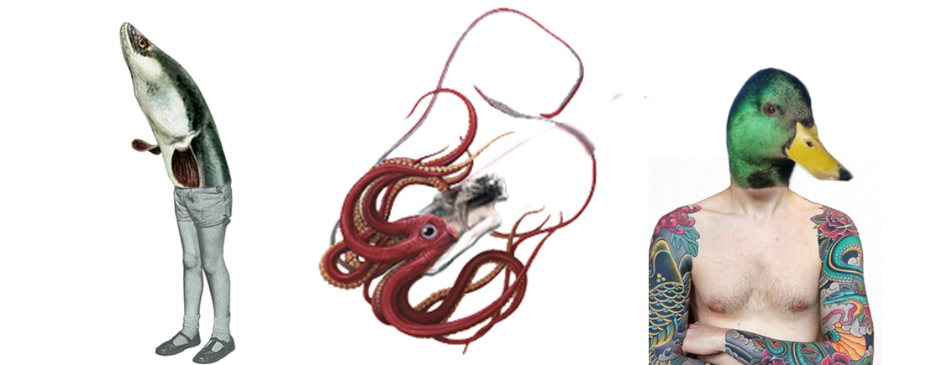

Image: Hybrids, Bureau LADA, 'Fisheye exhibition', OBA Amsterdam

3.2 Protagonist /topic

Choose and describe the protagonist of the story, a plant, animal or ecosystem, and create a desires map between two (or more) protagonists. Being able to empathize - understand the other's perspective or understand the conflict between them forms the basis for the narratives development.
Cleansing, producing, feeding and hosting are larger topics within which each student will choose a specific aspect to work on during the studio. Mapping layers of the topic together with describing desires, ambition and conflicts of the protagonists will create the narrative framework. This framework can also be seen as a programme of requirements.
Important theory and reading background for the studio clusters around thinking by Bruno Latour and the The Parliament of Things by Partizan Public. As Latour states, “Here lies the entire modern paradox. If we consider hybrids, we are dealing only with mixtures of nature and culture; if we consider the work of purification, we confront a total separation between nature and culture.”

3.3 Design process
This is an intensive design course and will require students to work extended hours during week 1 to week 6. The studio will cycle through six operations over six weeks; mapping and narrative outline, narrative collage and intuitive modelling, quick design and section, material and idea detail, the production of a narrative collage, documentation and reflection. Mid- semester crit will be your final submission.

The development and articulation of a concept, in a 'storytelling' way (design narrative) is the key driver of this design studio. Students will be asked to learn from their own intuition, in hand-made modelling and mapping, to develop listening and hearing skills, to design from another's point of view and appropriate these skills with spatial, technical and material knowledge.

4.0 TEACHING AIMS
The aims of this course are to:
Advanced Design 1 is the integrated design project for the MArch(Prof). Students are required to address a challenging and conceptually complex architectural design and to achieve a fully resolved design project, together with developed design studies sufficient to explain the proposed building’s construction, structure, materials and natural environmental performance. A report is required to elucidate the design.
Emphasis will fall upon the development of strategic responses to differing, changing or extreme environmental conditions. Focus on site, thermal, natural environment, material and ecological issues.

5.0 LEARNING OUTCOMES
General ARCHDES700 Course Outcomes
On successful completion of this course, students should be able to:
- Theory: Show evidence of development of critical thinking and conceptual consistency throughout the design process.
- Architectonics: Demonstrate abilities to advance conceptual thinking and design propositions through identifying and addressing issues of materiality, structure and construction.
- Performance: Show abilities to advance conceptual thinking and design propositions through interrogating and addressing in depth the natural environmental, contextual, and programmatic factors underlying the project.
- Form and Space: Demonstrate skill in the development of three dimensional architectural form and space, both exterior and interior.
- Media: Display skill in the communication and development of conceptual, preliminary and developed design propositions through the strategic use of architectural media.

Specific Topic Outcomes
- Theory: Demonstrate the ability to explore and develop a cohesive proposal, which engages with multiple scales - from the conceptual narrative, to the ecological landscape scale, to the site-specific scale, to the tactile and tectonic scale of the architectural design.

- Architectonics: Demonstrate the ability to engage with material, tectonics and detailing in relation to the larger scales and narrative.

- Programme: The design narrative requires skillful programming as evidence of engagement with identified ecological, cultural, social and functional positions, which inform the pursuit of architectural propositions. Demonstrate the ability to place oneself in the other's point of view. Show how did this inform your architectural programming.

- Performance: Show abilities to advance conceptual thinking through engagement with environmental and contextual conditions of the chosen waterscape. Examine and demonstrate how this chosen context affects the internal performance and spatial character of your design. Examine and demonstrate how your design in return affects its chosen context.

- Form and space: Demonstrate how the architectural form has been articulated by both the external 'water' condition as well as the interior spaces. Demonstrate how the interior spaces have been shaped by the external 'water' condition, programme and exterior form. A consideration of large-scale singular space, small-scale multiple spaces and how they influence each other is expected.

- Media: Demonstrate how the narrative design development, direct modeling and looking through an other's eyes has influenced the outcome of your project for the final presentation. Demonstrate the development of intuitive design ability; through working with hand-made intuitive models, and personalized mapping techniques. Develop listening and hearing skills; demonstrate design influences from an other's point of view.

6.0 COURSE STRUCTURE AND CONTENT

WEEK 1 | Blue Mapping
 | M 06.03.17  T 07.03.17  W 08.03.17  T 09.03.17  F 10.03.17 | 2-4pm  10:30  13:00  10:00  11:30  13:00  14:00  10:00  11:30  11:00  13:00 | Introduce studio topic  Students are informed of studios  Introduce studio, brief, outline schedule & begin mapping layers of Auckland’s waterscape  Round table discussion (1hr) – all present  Meetings with mapping groups to discuss waterscape. There will be a sign up sheet - 4th years with classes pick a time which suits  Lada at thesis charette (level 2 studio)  Further meetings with mapping groups  Round table discussion (1hr) – all present  Meetings with mapping groups to discuss waterscape. There will be a sign up sheet – 3rd years with classes pick a time which suits  Students present Auckland Waterscape map (pin up level 4, 1.5hrs). Some 3rd year students will have a class from 9 -12pm (please discuss this clash with your lecturer & ask if you can be excused 1hr early)  Deliver task for Monday: Choose two sites for next week that interest you within Auckland’s waterscape & list all of the actors (plants animals water etc) within or adjacent to these sites. Visit sites if possible.  Thesis charrette, Level 2 studio (our studio welcome)
WEEK 2 | Protagonist  M 13.03.17  T 14.03.17  W 15.03.17  T 16.03.17  F 17.03.17 | 10:00  13:00  14:00  10:00  13:00  14:00  10:00  11:30  10:00  11:30  1800  18:30  10:00  13:00  15:00 | Studio  Round table discussion (1hr) – all present with two sites and list of actors. Select one site to work on and develop. Choose and describe the protagonists of the story, a plant, animal or ecosystem, and create a desires map between two (or more) protagonists. Develop a narrative framework through a close interrogation of the desires, ambition and conflicts of the protagonists, the resources involved and applicable site specific data. (Show example projects)  1 to 1 meetings with students to discuss individual sites  Studio  Round table discussion (1hr) – all present with desire, ambition and conflicts maps. Map layers of cleansing, producing, feeding and hosting which exist (or could exist) within this framework. This framework is as a programme of requirements for a hybrid space you will design.  Make narrative collage / intuitive model (working)  1 to 1 meetings with students to discuss protagonists  Guest expert: Lucy van Oosterom, marine biology  Adjust narrative collage / intuitive model  1 to 1 meetings with students - there will be a sign up sheet – 4th years with classes pick a time which suits  Guest expert: tbc / Round table discussion (1hr)  Adjust narrative collage / intuitive model  1 to 1 meetings with students - there will be a sign up sheet – 3rd years with classes pick a time which suits  Lecture preparation  FAST FORWARD LECTURE: Lada Hrsak  Studio  Present protagonists, narrative and hybrid.  Output: desires map, mapping of chosen ecosystem, conceptual models and narrative collage  Set task for Monday
WEEK 3 | Inhabitation  M 20.03.17  T 21.03.17  W 22.03.17  T 23.03.17  F 24.03.17 | 10:00  13:00  14:00  10:00  13:00  14:00  1300  10:00  13:00  15:00 | Studio  Round table discussion (1hr) – all present with work.  Intuitively model a space for co-habitation between human and one other species related to water. (Based on protagnists & programme identified).  Cut a section through this a draw the relationship between internal space & surrounds.  1 to 1 meetings with students to discuss  Adjust narrative collage / intuitive modelling  Round table discussion (1hr) – all present with work.  Present working sections for feedback.  Make a series of models exploring the materiality of this internal or external condition.  1 to 1 meetings with students to discuss  no assigned studio time (Lada & Esther in Wellington)  1 to 1 meetings with students to discuss  Studio  Present spatial inhabition  Output: Section and a series of intuitive models (pin-up level 4, 1.5hrs)  Set task for Monday: Narrative Section  Collect content for section (at scale/ multiple scales)  Define one or two main materials & concept details  Define structural propositions, innovative and water-related building techniques, consider how this is presented in the section
WEEK 4 | Narrative  M 27.03.17  T 28.03.17  W 29.03.17  T 30.03.17  F 31.03.17 | 10:00  13:00  14:00  10:00  13:00  14:00  10:00  13:00  14:00  10:00  13:00  14:00  13:00 | Studio  Round table discussion (1hr) – all present with work.  discuss one or two main materials & concept details (direct students to Detail magazine)  discuss structural propositions, innovative and water-related building techniques  discuss how information / narrative is read across section  1 to 1 meetings with students to discuss  Studio  Round table discussion (1hr) – all present with work.  adjust material, define references  define narrative elements or 'storyboard'  1 to 1 meetings with students to discuss  Studio  Round table discussion (1hr) – all present with work.  print off draft narrative section to scale  adjust presentation materials (as it is work in progress adjust to be precise contentwise)  1 to 1 meetings with students to discuss  Studio  Round table discussion (1hr) – all present with work.  print off draft narrative section to scale  adjust presentation materials (as it is work in progress adjust to be precise contentwise)  1 to 1 meetings with students to discuss  Presentation (our midsemester crit)  Output: A narrative section comprising previous content (mapping, protagonist mapping, plans, sections, conceptual models)
WEEK 5 | Reflection  M 03.04.17  T 04.04.17  F 07.04.17 | 10:00  13:00  14:00 | Studio  Round table discussion (1hr) – all present with work.  Respond to feedback from Mid semester Crit & document work to date.  Specify areas for further enquiry, weaknesses within proposal and who to enlist (field experts) to build weight behind proposal  Write 300-400 words  1 to 1 meetings with students to discuss  No assigned studio time  No assigned studio time / send Esther & Lada documented projects (format TBC)
WEEK 6 | Water patterns  M 10.04.17  T 11.04.17  W 12.04.17  F 14.04.17 | 10:00  11:00  10:00  10:00  13:00 | Round table discussion (1hr) – all present with work.  Categorise projects, look for underlying strategies – ask students to reflect on larger patterns of ‘water development’ proposed  1 to 1 meetings with students to discuss  Studio / 1 to 1 meetings with students to discuss  Studio / 1 to 1 meetings with students to discuss  Final Crit  All work present. This is a formal submission
 |  |  | MID-SEMESTER BREAK
Week 7 |  |  | No assigned studio time
Week 8 |  |  | No assigned studio time
Week 9 |  |  | No assigned studio time
Week 10 |  |  | No assigned studio time
Week 11 |  |  | No assigned studio time
Week 12 |  |  | No assigned studio time

7.0 LEARNING RESOURCES

7.1 Required Reading
- Bruno Latour - http://blog.theparliamentofthings.org/into-latour/
- ‘Abundance & Constraint; a short history of water use in New Zealand http://www.glaw.net16.net/water%20history/abundance_and_constraint_.htm
- R.P.Scofield's 'A Naturalist of the Very First Order, Percy Earl in New Zealand' - https://www.researchgate.net/publication/259237321_A_Naturalist_of_the_Very_First_Order_Percy_Earl_in_New_Zealand
- Islands and Ecology by SAN ROCCO magazine - http://www.sanrocco.info/issues/11
- Chus Matrinez, 'Octopus in Love' - http://www.e-flux.com/journal/55/60304/the-octopus-in-love/

(Texts placed on short loan)
- Rayner Banham, 'The Architecture of Four Ecologies' (72.036.6(73) B21 )
- Dirk Sijmons, 'Landscape and Energy' (620.9 S579 )

7.2 Recommended or Supplementary Reading
We will provide you with further texts/ sources on day one

7.3 Other Materials or Software

7.4 Use of Canvas
We will notify you in studio should we place any texts on Canvas

7.5 Other Assistance / Student Support Available

8.0 INCLUSIVE LEARNING
Students are urged to discuss privately any impairment-related requirements face-to-face and/or in written form with the course convenor/lecturer and/or tutor.

9.0 OTHER INFORMATION
Please note that this is an intensive design course and will require students to work extended hours during week 1 to week 6. Final submission of all material will be Friday the 14th of April.

All consultation and discussions regarding this design paper will take place in timetabled studio contact time. Lada Hrsak will be in Auckland from Week 1 to Week 4 (06.03.17 – 31.03.17). Please note that this is an intensive design course and will require students to work extended hours at times and less at others. We will be in studio from 10am most days, effort has been made to schedule round tabel discussions in times where there are few clashes. However, it is up to you to manage your time.

Appointment sheets will be pinned up to facilitate this process. All students are to attend round-table discussions. Attendance in studio is mandatory. Should any issues that are inappropriate to discuss in studio arise please make an appointment to see Esther Mecredy via email – emecredy@gmail.com

10.0 ASSESSMENT

10.1 Method of Assessment
100% coursework
All student work is assessed by the named staff member(s) offering each course topic, who are appointed as examiners. Provisional grades are confirmed at an examiners’ review of the work of all students in that particular design course, in order to ensure parity of grading standards across course topics. All marks are indicative until confirmed in the Design Grading Moderation Review. All work presented for Advanced Design 1 is also reviewed by external assessors.

10.2 Assessment Criteria
Detailed information on assignment format and assessment criteria are provided below. The grading of work is based on the NICAI Grade Descriptors printed on the Faculty website: https://cdn.auckland.ac.nz/assets/creative/for/current-students/course-planning-enrolment/Planning-and-enrolment-assets/NICAI%20grade%20descriptors.pdf.

In addition to the criteria set out in the School handbook, assessment will be based on the following:
- Theory: Quality and consistency of conceptual and critical thought throughout the design process.
- Architectonics: Quality of design development through the creative engagement with issues of materiality, structure and construction.
- Performance: Depth of understanding of, and extent of design development demonstrated through creative engagement with, relevant natural environmental, contextual and programmatic factors underlying the project.
- Form and Space: Level of skill demonstrated in the development of three dimensional architectural form and space, both exterior and interior.
- Media: Quality of presentation, clarity of communication, appropriateness of media strategy and level of skill displayed through the work presented at all stages of the design process.
- Quality of engagement in studio – singularly, in group discussions and in formal crits. Attendance in studio and for the duration of crit days is mandatory – students are expected to support and learn from their colleagues.

Specific topics will weight the factors presented above according their identified emphases.

10.3 Academic Integrity
The University of Auckland will not tolerate cheating, or assisting others to cheat, and views cheating in coursework as a serious academic offence. The work that a student submits for grading must be the student’s own work, reflecting his or her learning. Where work from other sources is used, it must be properly acknowledged and referenced. This requirement also applies to sources on the world-wide web. A student’s assessed work may be reviewed against electronic source material using computerised detection mechanisms. Upon reasonable request, students may be required to provide an electronic version of their work for computerised review.

10.4 Attendance and Participation
Attendance in class as well as engagement with course activities and readings supports academic success. Therefore it is strongly recommended that students make every effort to attend class and complete all the necessary in-class requirements.

10.5 Output Requirements
Abstract: All AD1 students are required to furnish a Design Report. This will take the form of a 350-400 word abstract. An abstract is a condensed piece of writing that highlights the major aspects of your design project: the content, context, scope and outcomes of the design research. The abstract should be a finely crafted piece of text accompanied by a single image of your project. A template will be given and all abstracts must be submitted in the template both in print and in digital format (venue TBC). Draft to be submitted for mid-semester crits. Workshops on writing will be held in Week 4. All final Design reports are due on Thursday May 25th so that they can be published and circulated to your critics well ahead of crit week.

Outputs will be expected every Friday – requirements are noted on the schedule above, key critiques will be held on;
Week 4 Critique: A narrative section comprising work from previous four weeks - mapping, protagonist mapping, plans, material detail & intuitive models.
Week 6 Critique: Documentation & reflection of 6 week studio (along with the 350-400 word abstract mentioned above). All work must be present, this is your final submission.

11.0 STUDENT FEEDBACK
Students will be asked to complete an evaluation of the course at the end of the semester, usually on the morning of final presentation.

12.0 UNIVERSITY POLICIES AND GUIDELINES
This course is based on the university policies and guidelines. For further information, see the University and Faculty websites. On the Faculty website, the ‘Quick Reference Guide for New Students’ provides useful information on such things as key dates, where to go for help and advice, personal support and academic policies and procedures.

Students must note the following warning that applies to all material provided for this course. This includes printed material and electronic material, and material posted on Canvas. If you are not sure about the requirements, ask for clarification from the course coordinator.

COPYRIGHT WARNING NOTICE
This material is protected by copyright and has been copied by and solely for the educational purposes of the University under licence. You may not sell, alter or further reproduce or distribute any part of this course pack/material to any other person. Where provided to you in electronic format, you may only print from it for your own private study and research. Failure to comply with the terms of this warning may expose you to legal action for copyright infringement and/or disciplinary action by the University.

M. Ghioni, San Rocco editorial, number 'Ecology'
http://blog.theparliamentofthings.org/into-latour/
Latour, Bruno. We Have Never Been Modern. Harvard University Press, 1993‬, 30‬

