SCHOOL/DEPARTMENT: Architecture & Planning

COURSE OUTLINE: ARCHDES300 / Semester 1, 2017

GENERAL COURSE INFORMATION
Course Code: | ARCHDES300
Course Title: | Design 5
Points Value: | 30 points
Prerequisites: | ARCHDES200 or 210
Restrictions: | ARCHDES310
Course Director: | Prof Andrew Barrie, Room 335, Building 421, a.barrie@auckland.ac.nz
Course Co-ordinator: | Aprof Uwe Rieger, Room 544, Building 421, u.rieger@auckland.ac.nz>
Teaching Staff: | Manfredo Manfredini <m.manfredini@auckland.ac.nz>  Tanya Chalermtip and Angelo Bueno

2.0 CLASS CONTACT HOURS
Monday, Tuesday & Friday, 1pm – 5pm; Level 4 Design Studios, Building 421.

3.0 COURSE PRESCRIPTION
The Collected: An introduction to a complex architectural thinking. Examines both conceptual and exceptional spaces and develops an understanding of the corresponding architectural systems.
Play and the city
Shaping relational infrastructures to find the marvellous and the surprising in the city of spectacle
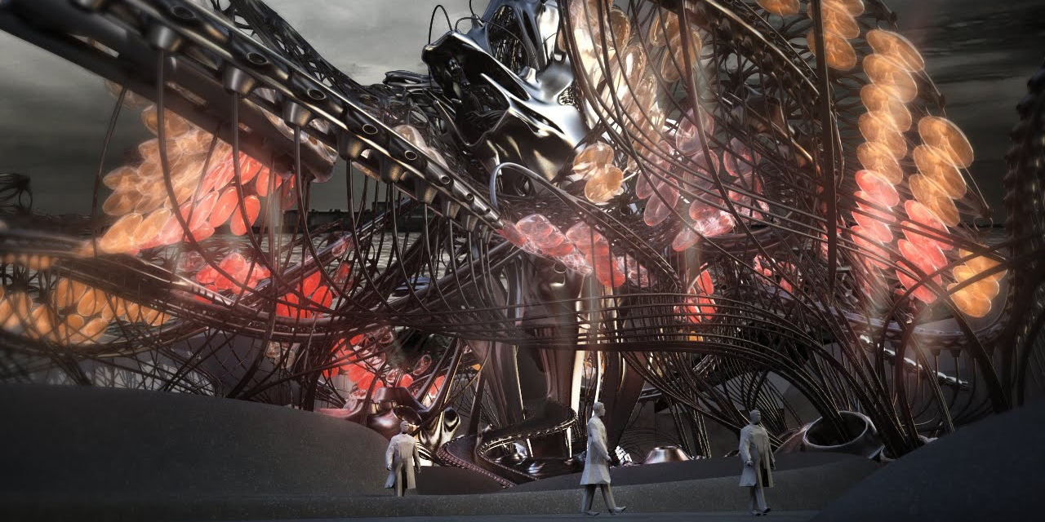
Emre Icdem, Excessive final, 2012-14

The design topic: a novel spatial paradox
Form and infrastructure of our cities progressively supports both the fragmentation and recombination of society, proposing design a novel spatial paradox. On one hand movement networks of everyday life increasingly expand, extending distances between homes, workplaces and amenities. Our collective experience in public space is more and more confined within carefully orchestrated places of consumption, like the shopping mall or entertainment parks. On the other hand, new recombinant factors emerging in urban public space counteract the growing disjunction and the effects of commodification and privatisation.
Cities like Auckland, with low population density and a political framework inspired by the free market doctrine, show this trend at its best and, alongside the decreasing vitality of what was once understood as genuine collective public space, show a progressive decline and marginalisation of the traditional urban commons. This has underpinned the recent development of major urban clusters of conspicuous consumption as key places for social relationships, characterised by a disconnected and semi-random aggregation of semi-public places. They are introverted eventful landscapes, dominated by the spectacle of enticing consumerist representations. Often, they are constituted by a single urban enclosure for retail and entertainment: the last generation of integrated shopping centres.
The new enclosures are the places that best express the continuous reframing of the spatial and social conditions of our post-consumerist, digital age. They are all-encompassing, having a networks of facilities and amenities that provide most of the goods and services needed in the everyday life of the local residents. In their realms, mixed realities are constantly generated and updated to provide new forms of engaging experiences, radically challenging the relations between architecture and the systems of associative life.
However, notwithstanding their central locations, relentless activity and great popularity, their spatio-social environments are strongly disjoined from those of their district. Large areas of sparsely populated “invaded space” (i.e. public space not devoted to public activities, such as carparks, arterial roads and transit areas) surround them. Precisely these latter spaces, for their extension, accessibility and connectivity, offer extraordinary opportunities for the reintroduction in the body of the city of great public places for the “social and cultural well-being of people and their communities” (Auckland Plan, 2012).

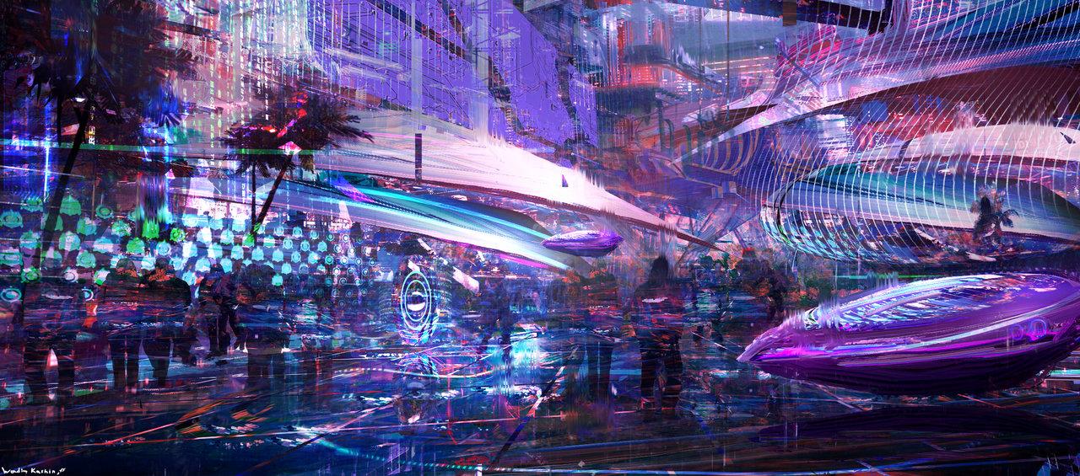
Wadim Kashin - SolarSouth, Night Life, 2014

3.2 The context of the design proposition: a node of the urban network
Auckland is experiencing a rapid expansion and strong “return to the centre” that is reflected in the great effort of the local government to produce high-quality public spaces and efficient public transport and cycling infrastructure. Its development, framed in the polycentric compact city model, is based on the intensification of few selected metropolitan centres. These include three major Emerging Metropolitan Centres located at the Northern (Albany), North Western (Westgate), and Southern (Sylvia Park) quadrants of the urban area, which all have major enclosure of shopping and entertainment at their core.
For their position and vocation, these centres constitute ideal experimentation laboratories, where architecture and urban design can effectively re-assemble the city. Students are free to decide whether any of them can be selected as location for their architectural proposition, however hyper-suburban, highly-unfinished or over-infrastructured areas are recommended.

3. 3 The design brief: an infrastructure for PLAY
Throughout this course, students will develop projects for a new kind of architecture: an infrastructure that interprets their own meaning of PLAY. PLAY will be explored using architecture to interpret its influence on relational, behavioural, perceptive public life. Research will produce speculative design propositions for an infrastructure to be built at the core of the new metropolitan centres to promote active life and public engagement. Design propositions will be developed elaborating a vision for the new public realm and considering programmatic, typological and phenomenological aspects in relation to the chosen site.
The exploration will engage with new spatialities, geared with the newest information technologies that prioritise the encounter with others and the sharing of experiences in environments that are not generated to obtain economic profit. To define the way these decommodified public space infrastructures will bring back PLAY in public life in its widest interpretation, students will choose one of the followings PLAY infrastructure programme:

PLAY AS CREATIVE GAMING: interactive engagement between multiple near and remote subjects for entertainment and fun for the production of original ludic and imaginative spatialities. Augmented Reality games (e.g. Pokemon Go and Batman Arkham VR) and immersive virtual/mixed reality sport environments (e.g. Laser Tag and Paintball) as well as traditional toy blocks games (as the ones used by Frank Lloyd Wright and Walter Gropius) or their modern adaptations (such as Minecraft) can contribute to set methods to generate evolutionary forms.

PLAY AS EVENTFUL PERFORMANCE: authored communicative action presented in front of participating audience for the production of representational spatialities. Spectator participation in performances such as outdoor concerts (e.g. Es Devlin’s hanging Kanye West set), political theatres (e.g. Berthold Brecht epic theatre) street events (e.g. block parties ad flash mobs) can instigate can co-creative spatial production.

PLAY AS SUBVERSIVE OR AGOINISTIC ACTIVITY: spontaneous, audacious, competitive or undirected journey, transforming movement in surprising, enchanting, unexpected or provoking engagement. (Re)creative infrastructure for skating, high-wire sliding or jumping and travelling on roller coasters as well as protesting, demonstrating, graffiti making and aimless strolling (dérive) can support the formation of political, insurgent or “unplanned” spatialities.

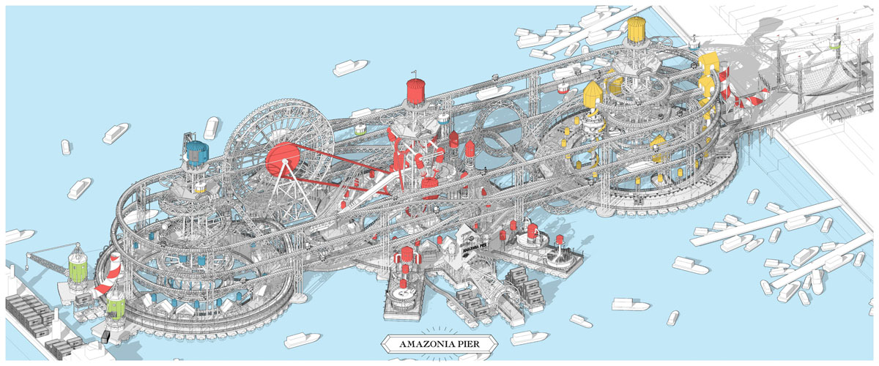
Julien Nolin, Amazonia Pier, 2016
4.0 TEACHING AIMS
The aims of this course are to:
Design 5 presents an introduction to complex architectural thinking. It examines both conceptual and exceptional spaces and develops an understanding of corresponding architectural methodologies and systems. Topics will explore the cutting edge of architecture, with an individual emphasis on the theoretical, contextual, architectonic, communicative, material, spatial, sociological or topographical.

5.0 LEARNING OUTCOMES
General ARCHDES300 Course Outcomes
On successful completion of this course, students should be able to:
- Theory: Show evidence of engagement with selected / prescribed areas of architectural theory and knowledge. Further, to show evidence of the exploration of the possible influence of this upon the development of architectural propositions.
- Architectonics: Demonstrate abilities to project, explore and develop the tectonic characteristics of the project through the creative engagement with material, structural or constructional propositions.
- Programme: Show evidence of engagement with identified cultural, social and functional positions as they might inform speculative architectural propositions.
- Performance: Show abilities to advance conceptual thinking through engagement with environmental and contextual conditions that could bear upon the project, and to examine the way in which the architecture may affect those same conditions in return.
- Form and space: Demonstrate abilities to develop speculative three dimensional architectural form and space.
- Media: Display skill in the communication and development of design propositions through the considered use of architectural media.

Specific Topic Outcomes
This studio topic will engage the general course outcomes in the following ways:
- Theory: Show evidence of engagement with the problems concerning inclusion, identity and difference, critical assemblage and ecological sensibility, in the design approach and in the definition of concept, objectives and methods for the architecture of public space, with particular focus on the relationships between physical, social and psychological spatialities.
- Architectonics: Demonstrate abilities to experimentally project, explore and develop tectonic and eidetic aspects dealing with diversity and ‘multitude’, through the creative engagement with material, structural and visual elements pertaining the collective space, and an appropriate use of digital media.
- Programme: Show evidence of engagement with a complex and multi-layered urban habitat, composing practices of communication, spectacle, consumption and recreation to improve the quality of a crucial place for the cultural, social and physical wellbeing of the wider community of one of the main centres of the Auckland conurbation.
- Performance: Show abilities to advance conceptual thinking combining theoretical and empirical research, and engaging with particularly complex urban conditions, through reading, interpretation and critical evaluation of scenarios and strategies in relation to the new forms of urbanity (the fast growing city of spectacle and consumption in the distributed megacity.
- Form and space: Demonstrate abilities to develop an innovative and site-specific architectural proposition with consistent relations between form, function, construction, materials and performances in each of the different design phases (meta-project, concept, design development, documentation and presentation).
- Media: Demonstrate advanced skills in the use of media in all the different design phases (meta-project, concept, design development, documentation and presentation).

6.0 COURSE STRUCTURE AND CONTENT

Week | Date | Topic
Week 1 | 6-12/03 | Introduction to the topic and preliminary research on the three sub-topics (in teams) with identification of the main (individual) objectives.
Week 2 | 13-19/03 | Identification and critical analysis of context and building site with delineation of the meta-project.
Week 3 | 20-26/03 | Critical appraisal of design precedents (individual - three sources of inspiration).
Week 4 | 27/03-2/04 | Definition of the design concept with exploration of speculative design processes.
Week 5 | 3-9/04 | Delineation of the masterplan.
Week 6 | 10-16/04 | Mid-semester crits
 |  | MID-SEMESTER BREAK
Week 7 | 1-7/05 | Finalisation/revision of the masterplan.
Week 8 | 8-14/05 | Design development.
Week 9 | 15-21/05 | Design development.
Week 10 | 22-28/05 | Production of the materials for the final presentation
Week 11 | 29/05-4/06 | Production of the materials for the final presentation and critical evaluation of results
Week 12 | 5-11/06 | Final Presentation

7.0 LEARNING RESOURCES

7.1 Required Reading

Texts will be provided during studio, according to individual research

7.2 Recommended or Supplementary Reading

Böttger, M., Davidson, D., Kelley, H., Kücklich, J. (2007). Space time play: Computer games, architecture and urbanism - the next level, Basel: Birkhauser Verlag AG.
Crawford, M. (1992). The World as a Shopping Mall, in Sorkin, M. (ed). Variations on a Theme Park: Scenes from the New American City, New York: Hill and Wang: 3-30.
Crawford, M. and M. Cenzatti (1993). Public Spaces and Parallel Worlds, Casabella, 597-598, January-February.
Dehaene, M. And De Cauter, L. eds. (2008). Heterotopia and the City: Public Space in a Postcivil Society, London: Routledge.
Ehrenhalt, A. (2013). The Great Inversion and the Future of the American City, New York: Vintage Books.
Garnett, N. (2012). Managing the Urban Commons, University of Pennsylvania Law Review, 160, 7: 1995-2027.
Gehl, J. (1987). Life between buildings: using public space, New York: Von Nostrand Reinhold.
Hodkinson, S. (2012), The new urban enclosures, City, 16: 500-518.
Jeffrey, A., McFarlane, C. and Vasudevan, A. (2012). Rethinking Enclosure: Space, Subjectivity and the Commons, Antipode, 44, 4, p. 1247-126.
Kayden, J.S. (2000). Privately owned public space: The New York City experience, New York: The New York City Department of City Planning, the Municipal Art Society of New York.
Koolhaas, R. (1994). Delirious New York: a retroactive manifesto for Manhattan, New York: Monacelli Press.
Lehnerer, A. (2009). Grand Urban Rules, Rotterdam: NAI 010.
Massey, D. (2005) For Space. London: SAGE.
Mould, O. (2015). Urban subversion and the creative city. London: Routledge.
Secchi, B. (2011). Isotropy vs. Hierarchy, Landscapes of Urbanism, Q5: 168-171.
Shane, D.G. (2005). Recombinant Urbanism: Conceptual Modeling in Architecture, Urban Design, and City Theory, London: Wiley-Academy.
Swyngedouw, E. (2000). Authoritarian Governance, Power, and the Politics of Rescaling, Environment and Planning D, Society and Space, 18(1):63-76
Totten, C. W. (2014). An architectural approach to level design. Boca Raton, FL, United States: A K Peters.
Walz, S. P., and Dessler, J. J. (2010). Toward a ludic architecture: The space of play and games. Pittsburgh, PA: ETC Press.

7.3 Other Materials or Software

7.4 Use of Canvas
Digital communication and access to digital materials will occur through Canvas

7.5 Other Assistance / Student Support Available

8.0 INCLUSIVE LEARNING
Students are urged to discuss privately any impairment-related requirements face-to-face and/or in written form with the course convenor/lecturer and/or tutor.

9.0 OTHER INFORMATION
Students are expected to attend all studio hours, actively participate in the class life and timey prepare analytical and creative documentation according to the teaching schedule, making them available to tutors and class.

10.0 ASSESSMENT

10.1 Method of Assessment
100% coursework
All student work is assessed by the named staff member(s) offering each course topic, who are appointed as examiners. Provisional grades are confirmed at an examiners’ review of the work of all students in that particular design course, in order to ensure parity of grading standards across course topics. All marks are indicative until confirmed in the Design Grading Moderation Review.

10.2 Assessment Criteria
Detailed information on assignment format and assessment criteria are provided below. The grading of work is based on the NICAI Grade Descriptors printed on the Faculty website: https://cdn.auckland.ac.nz/assets/creative/for/current-students/course-planning-enrolment/Planning-and-enrolment-assets/NICAI%20grade%20descriptors.pdf.

In addition to the criteria set out in the School handbook, assessment will be based on the following:
- Theory: Level of critical engagement with selected or prescribed areas of architectural theory and knowledge and the consideration of its bearing upon the design process.
- Architectonics: Ambition of the design project and the quality of design development through the creative engagement with material, structural and constructional issues.
- Programme: Quality of engagement with relevant cultural, social and functional issues to inform the pursuit of cutting edge architectural propositions.
- Performance: Extent of design development through the consideration of environmental and contextual conditions bearing upon the project.
- Form and Space: Quality of engagement with and development of speculative three dimensional architectural form and space.
- Media: Quality and clarity of presentation, the extent of design development facilitated by, and the consideration given to the architectural media utilised.
- Quality of engagement in studio – singularly, in group discussions and in formal crits. Attendance in studio and for the duration of crit days is mandatory – students are expected to support and learn from their colleagues.

Specific topics will weight the factors presented above according their identified emphases.

10.3 Academic Integrity
The University of Auckland will not tolerate cheating, or assisting others to cheat, and views cheating in coursework as a serious academic offence. The work that a student submits for grading must be the student’s own work, reflecting his or her learning. Where work from other sources is used, it must be properly acknowledged and referenced. This requirement also applies to sources on the world-wide web. A student’s assessed work may be reviewed against electronic source material using computerised detection mechanisms. Upon reasonable request, students may be required to provide an electronic version of their work for computerised review.

10.4 Attendance and Participation
Attendance in class as well as engagement with course activities and readings supports academic success. Therefore it is strongly recommended that students make every effort to attend class and complete all the necessary in-class requirements.
10.5 Output Requirements
Week | Date | Topic
Week 1 | 10/03 | Verbal presentation: sub-topics, with digital support (20 minutes per team).  Documentation: digital presentation
Week 2 | 17/03 | Documentation: short written manifesto (individual - 500 words), digital presentation  Verbal presentation: manifesto and meta-project, with digital support (5 min/student)
Week 3 | 24/03 | Verbal presentation: precedents, with digital support (5 minutes per student)  Documentation: digital presentation
Week 5 | 7/04 | Verbal presentation: conceptual proposal, with digital/analogue support (5 min/student)
Week 6 | 10-16/04 | Mid-semester crits  Verbal presentation of the concept and preliminary masterplan with digital/analogue support (10 min/student).
 |  | MID-SEMESTER BREAK
Week 9 | 19/05 | Verbal presentation: design development, with digital/analogue support (5 min/student).
Week 10 | 26/05 | Final presentation: planning and layout  Documentation: critical reflection on the project (1.000 words)
Week 12 | 5-11/06 | Final Presentation  Verbal presentation of the masterplan with digital/analogue support (15 min/student).  Documentation: digital and analogue materials

11.0 STUDENT FEEDBACK
Students will be asked to complete an evaluation of the course at the end of the semester, usually on the morning of final presentation.

12.0 UNIVERSITY POLICIES AND GUIDELINES
This course is based on the university policies and guidelines. For further information, see the University and Faculty websites. On the Faculty website, the ‘Quick Reference Guide for New Students’ provides useful information on such things as key dates, where to go for help and advice, personal support and academic policies and procedures.

Students must note the following warning that applies to all material provided for this course. This includes printed material and electronic material, and material posted on Canvas. If you are not sure about the requirements, ask for clarification from the course coordinator.

COPYRIGHT WARNING NOTICE
This material is protected by copyright and has been copied by and solely for the educational purposes of the University under licence. You may not sell, alter or further reproduce or distribute any part of this course pack/material to any other person. Where provided to you in electronic format, you may only print from it for your own private study and research. Failure to comply with the terms of this warning may expose you to legal action for copyright infringement and/or disciplinary action by the University.

